 | SAKR MANNING AGENCY  FOR RECRUITING EGYPTIAN LABOR ABROAD | Issue Date | 15.05.2022
 |  | Revision Date | 19.07.2022
 | Crewing Management Manual  Seafarer Employment Application | Revision | 1.1
 |  | Page | 3
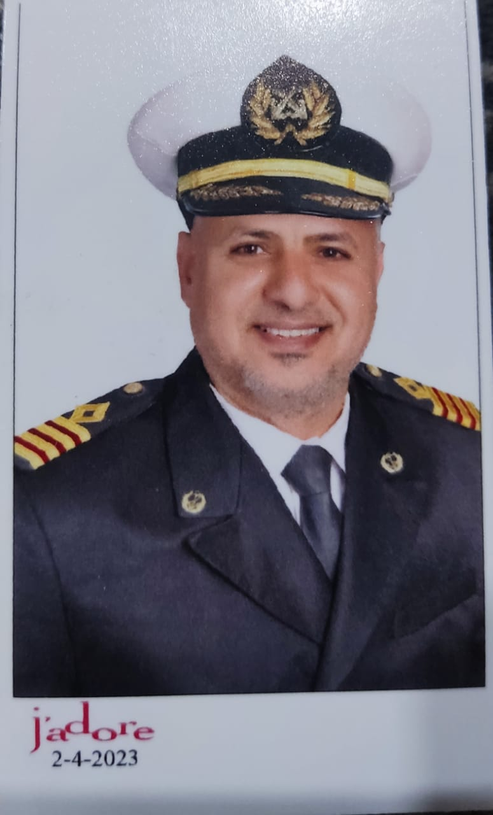
Application For Position as | CHIEF`ENGINEER
Register Code. | EO-2.016
Other Position (If Any)
Register Date | 5/11/2023
Last up Date Data
Expected Salary

1. PERSONAL DETAILS
Full Name |  | Yasser Attia Hassan Elsayed
Date Of Birth |  | 05/01/1975 |  |  |  |  |  |  | Place Of Birth |  |  |  |  |  |  |  | Dakahliya
Nationality |  | Egyptian |  |  |  |  |  |  | Marital Status |  |  |  |  |  |  |  | Single |  |  |  |  |  |  |  | Married x
Height (Cm) |  | 180Cm |  |  |  |  |  |  | Overall Size |  |  |  |  |  |  |  | 2XL |  |  |  |  | Shirt Size |  |  |  |  |  | 2XL
Weight (Kg) |  | 90`kg |  |  |  |  |  |  | Trouser Size |  |  |  |  |  |  |  | 40 |  |  |  |  | Shoes Size |  |  |  |  |  | 44
2. EDUCATION
College / School |  | Marine Academy
Marline Test |  | Issued Date |  |  |  |  | Result % |  |  |  | Issued By (Authority) |  |  |  |  |  |  |  |  |  | Issued At
English Language |  | Fluent |  |  |  |  |  | Good x |  |  |  |  | Average |  |  |  |  |  |  |  | Poor
……… Language  ( ) |  | Fluent |  |  |  |  |  | Good |  |  |  |  | Average |  |  |  |  |  |  |  | Poor
3. CONTACT DETAILS
Home Address / City |  |  | ELsenblawen`Dakahliya
E-Mail |  |  | Yaseratia89@gmail.com |  |  |  |  |  |  | Mobile / Tel |  |  |  |  |  | 00201557063098 |  |  |  |  |  |  | 00201004691848

4. TRAVEL DOCUMENTS
Type |  | Document No. |  |  |  | ISS. Date |  |  | Exp. Date |  |  |  |  | ISS. By (Authority) |  |  |  |  |  |  |  |  |  | Place of Issue
Passport |  | A37311513 |  |  |  | 02/04/2024 |  |  | 01/04/2031 |  |  |  |  | Egyptian Authority |  |  |  |  |  |  |  |  |  | Dakahliya
Seaman Book |  | S00030290 |  |  |  | 05/04/2023 |  |  | 31/07/2027 |  |  |  |  | EAMS |  |  |  |  |  |  |  |  |  | Alex.
Other Seaman Book |  | PA0300383 |  |  |  | 17/10/2022 |  |  | 30/07/2023 |  |  |  |  | PANAMA |  |  |  |  |  |  |  |  |  | PANAMA

5. PROFESSIONAL QUALIFICATION / CERTIFICATE OF COMPETENCY
Certificate Name |  |  |  |  | Number | Issue Date |  |  |  |  |  | Expiry Date |  |  |  |  |  | Issued By |  |  |  |  |  |  |  |  | Issued At
COC |  |  |  |  | 4267 | 04/04/2023 |  |  |  |  |  | 31/07/2027 |  |  |  |  |  | EAMS |  |  |  |  |  |  |  |  | Alex.
GOC |  |  |  |  |  |  |  |  |  |  |  |  |  |  |  |  |  | NTRA |  |  |  |  |  |  |  |  | Cairo
D.P. INDUCTION
D.P. ADVANCED
D.P. OPERATOR (UNLIMITED)
6. NEXT OF KIN
Full Name | Yasser`Attia`Hassan`Elsayed |  |  |  |  |  |  |  |  |  |  |  |  |  | Relationship |  |  |  |  | Married
Address | ELsenblawen`Dakahliya
Tel. No. | 00201004691848 |  |  |  |  |  |  |  |  | Mobile |  |  | 00201557063098
7. HEALTH CERTIFICATES & VACCINATIONS
Flag State |  |  |  | Number |  |  | Issue Date |  |  |  |  | Expiry Date |  |  |  |  |  |  | Issued By |  |  |  |  |  |  | Issued At
International Medical |  |  |  |  |  |  | 16/04/2023 |  |  |  |  | 15/04/2025 |  |  |  |  |  |  | EAMS |  |  |  |  |  |  | Alex.
Yellow Fever |  |  |  | 068 |  |  | 28/03/2020 27/03/2029 |  |  |  |  | 27/03/2029 |  |  |  |  |  |  | Ministry of Health
Cholera |  |  |  |  |  |  |  |  |  |  |  |  |  |  |  |  |  |  | Ministry of Health
Covid-19 |  |  |  | Vaccination Name |  |  | First Dose |  |  |  |  | Second Dose |  |  |  |  |  |  | (Other Does or Remarks)
 |  |  |  | 11001211045197190821 |  |  | 13/03/2021

8. MARINE COURSES
Course Name | Number | Issue Date | Expiry Date | Issued By / At
Personal Survival Techniques
Proficiency In Personal Survival Techniques | 9683/23/EG | 21/03/2023 | 20/03/2028 | EAMS / Alex.
Fire Prevention and Fire Fighting
Advanced Fire Prevention and Fire Fighting | 10002/23/EG | 26/03/2023 | 22/03/2028 | EAMS / Alex.
Elementary First Aid | 10968/23/EG | 30/03/2023 | 29/03/2028 | EAMS / Alex.
Medical Care Studies
Personal Safety and Social Responsibilities | 10954/23/EG | 30/03/2023 | 29/03/2028 | EAMS / Alex.
Proficiency Of Security Awareness Training Seafarers | 8477/23/EG | 14/03/2023 | 12/03/2028 | EAMS / Alex.
Proficiency as a ship Security officer ( PSSO )
Proficiency In Survival Craft & Rescue Boats | 10874/23/EG | 30/03/2023 | 27/03/2023 | EAMS / Alex.
G.M.D.S.S
Communications
Advanced Communications
ECDIS Advanced Simulator (Management Level)
ECDIS Simulator (Operation Level)
Prevention and Combating of Marine Pollution
Radar & ARPA Simulator and Search &rescue
ARPA Simulator and Search
Marine Radar and automatic Radar Plotting
Bridge resource Management (B.R.M)
Engine resource Management (E.R.M) | 8620/23/EG | 15/03/2023 | NON | EAMS / Alex.
Navigational Watch keeping
Proficiency for Rating forming part of Navigational watch (II/4) |  |  |  | EAMS / Alex.
High voltage training – operation of ship (1000 Volt and More) | 9228/23/EG | 28/03/2023 | NON | EAMS / Alex.
Passenger Safety Cargo Safety and Hull integrity
Crowd Management Training
Crisis Management and Human Behavior Training
Safety training for Personal Prov. Direct Passengers
Practical Ability to Prepare Meals and (MLC 2006)
Personal Hygiene and Envir. Protection (MLC 2006)
Safety and Health in the Provision Meals (MLC 2006)
Food Storage and inventory Control (MLC 2006)
Ships Cook Certificate (MLC 2006) |  |  |  | EAMS / Alex.
Abel Seafarer Deck
Proficiency for Abel Seafarer Deck ( II/5 ) |  |  |  | EAMS / Alex.
Engineering Watch keeping |  |  |  | EAMS / Alex.
Proficiency for Rating forming part of a watch in engine room
Abel Seafarer Engine
Proficiency for Abel Seafarer Engine ( III/5 ) |  |  |  | EAMS / Alex.
Electro Technical Rating
Proficiency for Electro Technical rating ( III/7 ) |  |  |  | EAMS / Alex.
Awreness`of`safety`Proeedures`Hydrogen`Sulfide`H2S | TSTC02288 | 24/10/2021 | 23/10/2023 | EAMS / Alex.

2
Name: |  |  |  |  |  |  |  | Rank: |  |  |  |  |  |  |  | Register Code:
Company Name |  |  | Rank |  | Vessel Name |  |  |  | Signed On |  |  | Signed Off |  |  |  | Period |  |  | Vessel Type |  | D.W.T. |  |  |  |  | Engine Type |  |  | BH | KW
MASSI SHIPING |  |  | CHIEF  ENGINEER |  | ADELINE |  |  |  | 30/12/2024 |  |  | 19/08/2025 |  |  |  | 8 MONTH |  |  | TANKER |  | 18500 |  |  |  |  | MAK 32 |  |  |  | 4500
ORINT SEAS |  |  | CHIEF  ENGINEER |  | SEA WAVE 2 |  |  |  | 01/09/2024 |  |  | 02/12/2024 |  |  |  | 4 MONTH |  |  | RORO  GARGO SHIP |  | 6650 |  |  |  |  | MAK |  |  |  | 7340
SOL MARINE |  |  | CHIEF  ENGINEER |  | ARBOL |  |  |  | 19/04/2024 |  |  | 12/08/2024 |  |  |  | 4 MONTH |  |  | TANKER |  | 15500 |  |  |  |  | MAN B& W |  |  |  | 4440
ORINT SEAS |  |  | CHIEF  ENGINEER |  | SEA WAVE1 |  |  |  | 05/05/2023 |  |  | 29/02/2024 |  |  |  | 10 MONTH |  |  | RORO  GARGO SHIP |  | 7095 |  |  |  |  | WARTSILA |  |  |  | 3300
ROCK`TREE |  |  | CHIEF  ENGINEER |  | NEW  CHALLNGE |  |  |  | 24/07/2022 |  |  | 03/03/2023 |  |  |  | 7month |  |  | BULCK |  | 20000 |  |  |  |  | MAN B& W |  |  |  | 3190
LDPL MIDDLE EAST |  |  | CHIEF  ENGINEER |  | ALM Aries |  |  |  | 14/11/2021 |  |  | 13/03/2022 |  |  |  | 4month |  |  | BULCK |  | 20000 |  |  |  |  | MAN B& W |  |  |  | 3190
SEAWAY OFFSHORE |  |  | 2ND`Enginer |  | DEEP`SEA`WORKER |  |  |  | 06/09/2020 |  |  | 12/08/2021 |  |  |  | 11month |  |  | MPSV`DP2 |  | 3345 |  |  |  |  | MAK |  |  |  | 4720
SEAWAY OFFSHORE |  |  | 2ND`Enginer |  | DEEP`SEA`WORKER |  |  |  | 123/12/2019 |  |  | 04/08/2020 |  |  |  | 8month |  |  | MPSV`DP2 |  | 3345 |  |  |  |  | MAK |  |  |  | 4720
ALL`AMAR`MARINE |  |  | 2ND`Enginer |  | PRINCESS NABIHA |  |  |  | 02/08/2019 |  |  | 11/12/2019 |  |  |  | 4month |  |  | MPP HEAVY  LIFT |  | 5822 |  |  |  |  | MAK |  |  |  | 5280
ALL`AMAR`MARINE |  |  | 2ND`Enginer |  | MAKKAH |  |  |  | 22/04/2019 |  |  | 01/06/2019 |  |  |  | 3month |  |  | AHTS`DP1 |  | 1000 |  |  |  |  | MTU |  |  |  | 3200
ALL`AMAR`MARINE |  |  | 2ND`Enginer |  | PLESSING |  |  |  | 24/09/2018 |  |  | 03/04/2019 |  |  |  | 6month |  |  | General 'Cargo&  container |  | 7578 |  |  |  |  | DEUTZ |  |  |  | 4350
ALL`AMAR`MARINE |  |  | 2ND`Enginer |  | VIRTUE |  |  |  | 05/04/2017 |  |  | 15/12/2017 |  |  |  | 8month |  |  | AHTS`DP1 |  | 3000 |  |  |  |  | MAN&BW |  |  |  | 3600
ALL`AMAR`MARINE |  |  | 2ND`Enginer |  | RADWA2 |  |  |  | 20/08/2016 |  |  | 12/02/2017 |  |  |  | 4month |  |  | RORO |  | 6500 |  |  |  |  | DEUTZ |  |  |  | 4200
ALL`AMAR`MARINE |  |  | 2ND`Enginer |  | VIRTUE |  |  |  | 08/04/2015 |  |  | 25/03/2016 |  |  |  | 11month |  |  | AHTS`DP1 |  | 3000 |  |  |  |  | MAN&BW |  |  |  | 3600
ALL`AMAR`MARINE |  |  | 2ND`Enginer |  | MAKKAH |  |  |  | 14/09/2012 |  |  | 02/02/2015 |  |  |  | 2.5yaers |  |  | AHTS`DP1 |  | 1000 |  |  |  |  | MTU |  |  |  | 3600
TRUST MARINE |  |  | 3rd`Eginer |  | OMNIA |  |  |  | 14/09/2011 |  |  | 10/12/2011 |  |  |  | 2month |  |  | General 'Cargo |  | 5000 |  |  |  |  | MAN&BW |  |  |  | 3970
ELSALAM MARINE |  |  | 3rd`Eginer |  | ELSALAM 89 |  |  |  | 31/08/2010 |  |  | 20/04/2011 |  |  |  | 8month |  |  | RORO |  | 7200 |  |  |  |  | PALSTIC
SPECIALISED EXPERIENCE
Name |  |  |  |  |  |  |  |  |  | Type |  |  |  | From |  |  | To |  |  |  |  | Comments
I declare that the information I have given is, to the best of my knowledge, true and complete. I also declare that the documents submitted are genuine, given and sign by persons whose names appear on them.
 |  |  |  |  |  |  |  |  |  |  |  |  | 19/04/2023 |  |  |  |  |  |  |  |  |  | Yasser`attia`hassn
 |  |  |  |  |  |  |  |  |  |  |  |  |  |  | DATE |  |  |  |  |  |  |  |  |  | SIGNATURE

